Super Simple Songs

https://supersimple.com/

Great Website https://loving2read.com/kindergarten/

Math
https://youtu.be/pZw9veQ76fo

FYI
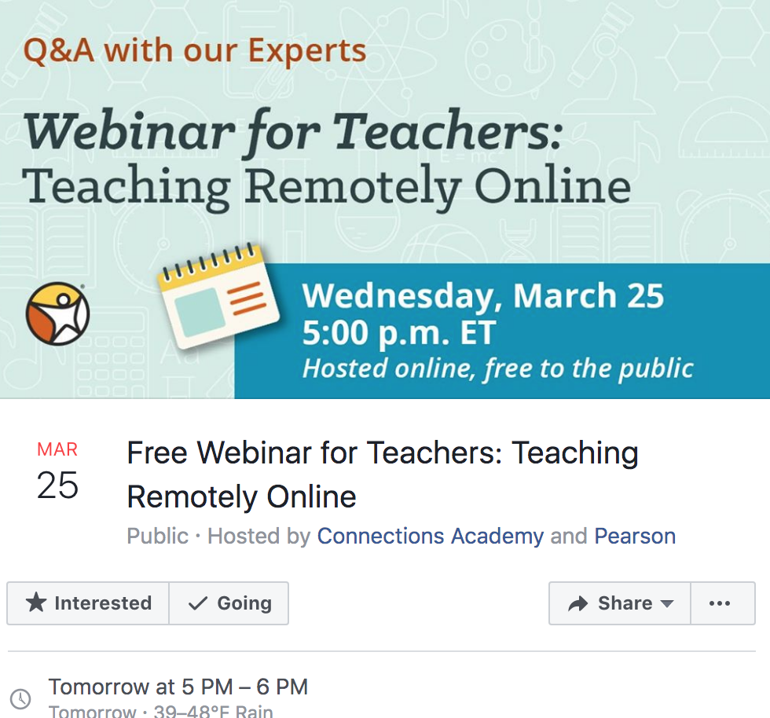

Teachers, join online education experts for this informative and very real conversation about taking your teaching online during this challenging time. Our panel will discuss how to engage students remotely, best practices for effective communication, how best to assess student work, tips for video tutorials and more.

The panel will be followed by a Q&A session for attendees.

The webinar will be hosted through Zoom:
https://zoom.us/j/208390838

We suggest signing on 10 minutes prior to the event.

