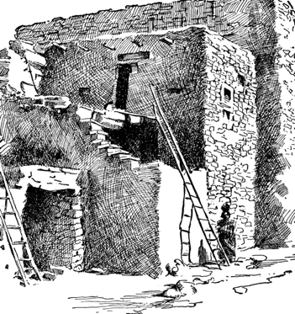 5th Grade Unit 1: USA
Grade: 5th Unit: 1 Time Frame: September-November Essential Question: To What Degree Does Geography Determine Culture? How do key forces and events shape a nation?
Focus Questions: What is the geologic history of the Western Hemisphere?
How is the geography of the Western Hemisphere unique?
How does geographic features and regional characteristics influence human settlement, land use and economic activity?
How did early people adapt to their environment?
What were the accomplishments of the early people?
How did geography, early people, and key events influence the development of the Western Hemisphere?
How did European exploration affect Native American peoples?
How did the columbian Exchange reshape the lives and beliefs of people?
What were the conditions experienced by enslaved Africans during the Middle Passage?
How does a country’s interpretation of its history reflect on its culture?
How have forces and events in United States history lead to the growth and transformation of the nation?
Student Outcomes:
*Understand the geographical factors that have affected the development of the Western Hemisphere  *Draw conclusions about native peoples based on archaeological evidence  *Use multiple resources to locate information about the geography and the early peoples of the Western  Hemisphere  *Students use a variety of specialized maps to analyze and evaluate how the physical environment of the United States influence human population distribution, land use, and economic activity. | *Describe and compare societies in the Western Hemisphere  *Compare and contrast native groups and how they adapted to their environments  *Analyze accomplishments of early peoples and how they affected the development of the Western Hemisphere  * Using primary and secondary sources, students analyze key events related to three common elements historically found in the growth of new nations: cause and effect, different perspectives and conflict
Assessment: Unit 1 Vocabulary Assessment using Plickers; End of Unit Test Multiple choice and DBQ | End of Unit: Choose 1:  1.Group Project : Create a poster to showcase geography, culture and history (including Native American Groups and Explorers)  Student Created Rubric  2. Region Brochure : showcase geography, culture, history (Including Native American groups and Explorers)
Extension Activities: 1. Visit the National Museum of the American Indian and sketch 3-5 items from a Native American group from and explain its importance to the group National Museum of the American Indian: One Bowling Green, Manhattan- The museum is open daily 10am – 5 pm except Thanksgiving Day and Christmas Day Admission is free

2. Model of Native American Home from region of choice
3. Create a diorama or poster to show life during Western Expansion (Gold Rush, Oregon Trail, or Homesteading)
