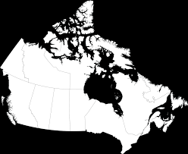

5th Grade Unit 3 : Canada
Grade: 5th Unit: 2 Time Frame: Mid April -May
Essential Question: How do key forces and events shape a nation?
Focus Questions:
How do geographical features and regional characteristics influence human settlement, land use, and economic opportunities?
How did the early people adapt to their environment?
What were the accomplishments of the early people?
How did European exploration affect Native American people?
the country over time?
How are the culturally rich traditions across Canada a reflection of the diversity of the nation?
How have forces and events in the history of Canada led to the growth and transformation of the nation?
In what ways does the political system in Canada address the needs of the diverse people of the nation?
What factors have shaped the economic development challenges in Canada?

Student Outcomes:
* Develop an understanding of historical continuity  and change.  • Recognize that the culture and beliefs of Canadian  provinces are a reflection of the people who make  up the area.  • Learn that Canada faced challenges and  opportunities in its growth and transformation.  • Identify major natural resources and industries of  Canada in order to discuss their impact on the  economy.  • Interpret visual and textual documents to evaluate  events surrounding the Klondike Gold Rush in  the 1890s.  • Evaluate differing views on the Keystone Pipeline and  write a persuasive letter stating their perspective.  • Consider different viewpoints about the Canadian  national anthem and debate the pros and cons  of changing its lyrics by passing a law to reflect  changing attitudes. | • Use a timeline to categorize divergent perspectives of  immigration policy in Canada, distinguishing between  the long-term and immediate causes and effects on  Canadian history.  • Explore a local issue—the mining of the Alberta tar  sands—to determine the long- and short-term effects  the issue has on the economy, environment, and the  health of the local community.  • Form opinions about the causes and effects of  current events in Canada today, including issues of  civil rights.  • Describe how human activity affects the physical  environment and leads to changes in local economies.
Assessment: 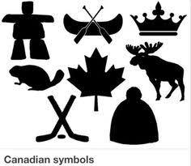 | End of Unit: Choose 1:  1. Power Point Presentation: geography, culture , history  2. Compare and Contrast Canada to either Mexico or USA
Assessment: End of Unit Quiz

