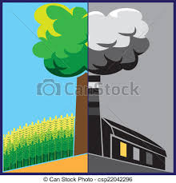
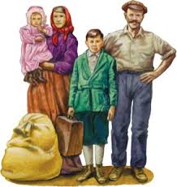
Grade: 4th Unit: 5 Time Frame: May 11 - June 26
Essential Question: How do people, laws, and new technology shape a nation?
Focus Questions: (What is my child thinking about?)
• How did the Industrial Revolution change the way people lived and worked?
• How did industrial growth and technological advancements change New York?
• How did New York City emerge as an economic power?
• What was the immigrant experience in New York City?
Student Outcomes: (What can my child do after this unit is over?)
- Evaluate how improvements and inventions in transportation and communication changed New York and America.
- Determine how urbanization changed New York City.
- Articulate the effects of migration and immigration on New York
- Interpret primary source documents.
- Ask authentic questions.
- Distinguish between fact and opinion.
- Recognize that specific events caused specific outcomes on a small and large scale
Performance Tasks: (End-of-Unit tasks) | Formative Assessment:
- Take an exam to assess their content knowledge of the growth of New York City/State (this unit) and the content learned the whole year | - Answers to multiple-choice questions about Social Studies content information that were examined during that period  - Use of Google Classroom activities to write down information about what they are learning about  - Answers to inquiry based questions about debatable issues throughout the time period
Extension Activities: If you are interested in learning more, there are so many interesting people things that you can read and write about. You can research this time period on your own and create a book or write an essay with your findings, thoughts, and ideas. Here are some ideas to get you started:
• Research: What was life like for an immigrant arriving at Ellis Island and settling in New York City?
• Informational Writing: How does the Erie Canal work? Why is it so important for New York State?
• Opinion Writing: City Living vs. Farm Life– what was the best option?
• Book Making: Create a “Survival Guide” pamphlet for an immigrant passing through Ellis Island and moving to New York City in the early 1900s.

