The P.E. January Physical Education News Letter

It is hard to believe we are already in the month of January! We continue to see progress in all of our student’s ability to safely share a space while being engaged in learning the sport of Tennis while continuing fitness. These physical fitness activities include sit-ups, push-ups forward lunges, jump roping, controlled breathing exercises, weighted wall-sits, jack squats, bicep curls, triceps curls, burpees, and mountain climbers to working on upper and lower body strength. The P.S.89’s first ever basketball team started practicing this month! Games will start in January and last until June. Game schedules will be posted soon!

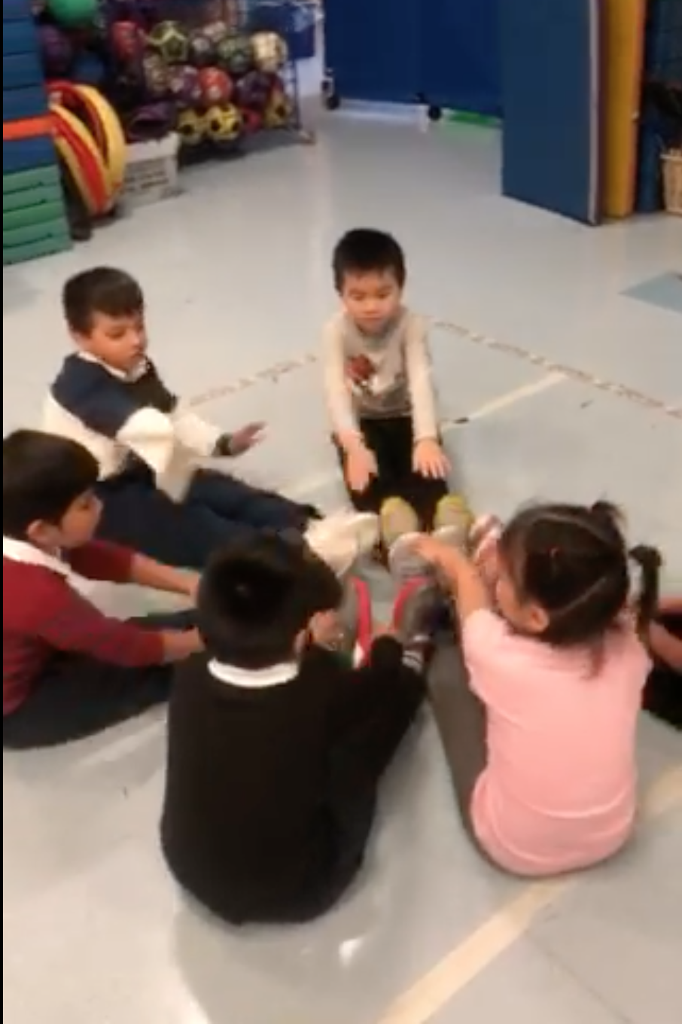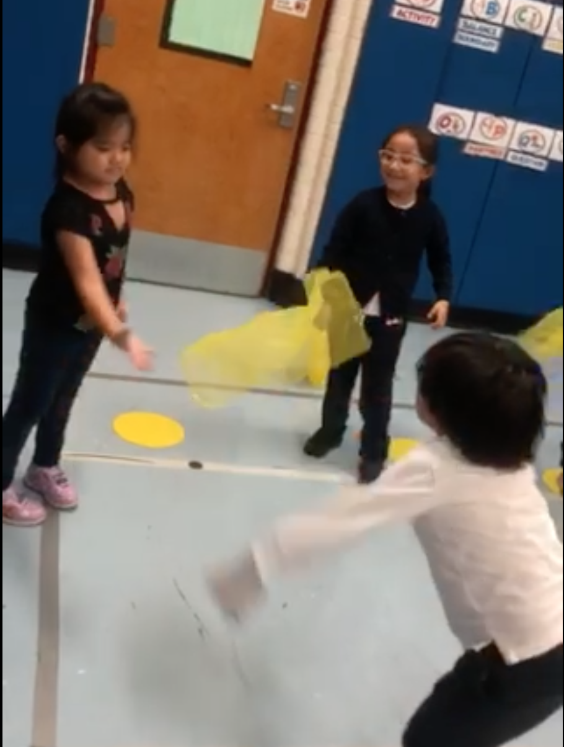

In this frigid January month, grades 2-5 student athletes are learning the sport of Tennis. We continue to focus on new sports that student athletes are not normally exposed to.
The P.E. Team focuses on:

- Learning how to hold the tennis racket (safety)
- Hand Eye Coordination (Visual Tracking), Control, accuracy, and proper foot work
- Forehand grip, backhand grip, serve, and rally

Students K-1 are working on the skill of dribbling.
The P.E. Team focuses on:

- Dribbling stationary & in motion
- Using dominant hand vs non-dominant
- Control, accuracy, and proper footwork

The P.E. department also implements physical fitness every month in stations as well as data collection with IPads in order to progressively show improvement. The P.E. department also showcases student’s talents via fitness movies.

In addition to this physical activity, student athletes are often given a chance to:

- Share ideas by discussing health & fitness misconceptions
- Practice public speaking and provide constructive criticism
- Learn breathing techniques

Thank you for your support and we look forward to the second half of the school year!
-The P.E. Team

