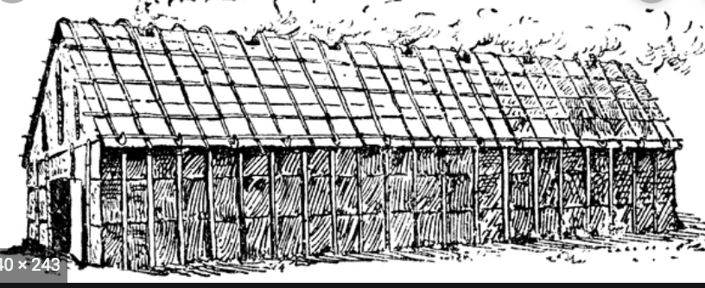

Grade: 4th Unit: 2 Time Frame: late December-January
Essential Question: What makes a complex society?
Focus Questions: (What is my child thinking about?)
• How did the environment and natural resources influence the development of Native American cultures in New York?
• How were roles, responsibilities, and power defined in Native American cultures?
• How did Native American cultures in New York organize their families and communities?
• How were roles, responsibilities, and power defined in Native American government?
• How did Native American cultures influence and contribute to the development of New York and the United States?
• How have the Haudenosaunee contributed to our lives today?
Student Outcomes: (What can my child do after this unit is over?)
• Evaluate why geography mattered in where Native Americans decided to settle
• Investigate how Native Americans adapted to and modified their environment
• Define and understand what a complex society is
• Determine how Native Americans relied on natural resources and the environment for survival
• Examine the gender roles and everyday lives of men, women, and children in Native American societies
• Explain how the cultural contributions of Native American cultures influence New York State today
• Analyze and synthesize a variety of nonfiction text and primary sources about the cultural structures/elements of Native Americans in New York State to prove their society is complex
Performance Tasks: (End-of-Unit tasks) | Formative Assessment:
- Create a poster showing different elements of the Native Americans’ complex society  =OR=  - Write a historical fiction diary entry for a man, woman, boy or girl living in a Native American society  - Take an exam to assess their content knowledge of Native Americans’ society | - Answers to multiple-choice questions about Social Studies content information that were examined during that period  - Use of notebook to write down information about what they are learning about
Extension Activities
• Research: How was the Lenape society similar or different to the Haudenosaunee society?
• Informational Writing: What made the Haudenosaunee society complex?
• Opinion Writing: What was the Haudenosaunee’s greatest contribution to American life?
• Map Making: Create a map to show where the Haudenosaunee lived in relation to current cities in NYS
• Book Making: Create an informational book about the Haudenosaunee.
• Model Building: Create a 3-dimensional model of a longhouse

